CPU SCHEDULING ALGORITHM
COMPARISON REPORT
Priority Scheduling vs. Shortest Remaining Time First (SRTF)

1. Introduction
CPU scheduling is a fundamental function of operating systems that determines the order in which processes are assigned to the CPU. An efficient scheduling algorithm minimizes process waiting time, maximizes CPU utilization, and ensures fair resource allocation among competing processes.
This report presents a comprehensive comparison between two preemptive CPU scheduling algorithms: Priority Scheduling and Shortest Remaining Time First (SRTF).

2. Algorithm Descriptions
2.1 Priority Scheduling (Preemptive)
Priority Scheduling assigns each process a priority number, and the CPU is always allocated to the highest-priority process in the ready queue. In this implementation, a lower numerical value indicates higher priority (i.e., Priority 1 is the most urgent).
Key characteristics:
- Preemptive: a higher-priority arriving process immediately preempts the running process.
- Tie-breaking: when two processes share the same priority, the one with the earlier arrival time is selected.
- Starvation risk: low-priority processes may wait indefinitely if higher-priority processes keep arriving.
- Best suited for: real-time systems where task urgency is well-defined and predictable.

2.2 Shortest Remaining Time First (SRTF)
SRTF is the preemptive variant of Shortest Job First (SJF). At every time unit, the scheduler selects the process with the shortest remaining burst time. If a newly arrived process has a shorter remaining time than the current process, it preempts it.
Key characteristics:
- Optimal average waiting time: SRTF is theoretically optimal in minimizing average waiting time.
- Tie-breaking: when two processes share the same remaining burst time, the one with the earlier arrival time is selected.
- Starvation risk: long processes can be starved if short processes keep arriving.
- Priority blindness: SRTF ignores priority numbers entirely — a short low-priority process will preempt a long high-priority one.
- Practical limitation: requires knowing burst times in advance, which is not always feasible in real systems.
3. Scenario Results

Scenario 1: Basic
A general-purpose workload with four processes of mixed arrival times, burst times, and priorities. This is the normal-case scenario designed to observe typical algorithm behavior.

Input Processes:
Process ID | Arrival Time | Burst Time | Priority
P1 | 0 | 8 | 3
P2 | 1 | 4 | 1
P3 | 2 | 9 | 4
P4 | 3 | 5 | 2

Priority Scheduling Results:
PID | AT | BT | PR | FT | TAT = FT - AT | WT = TAT - BT | RT = First CPU - AT
P1 | 0 | 8 | 3 | 17 | TAT = FT - AT = 17 - 0 = 17 | WT = TAT - BT = 17 - 8 = 9 | RT = First CPU - AT = 0 - 0 = 0
P2 | 1 | 4 | 1 | 5 | TAT = FT - AT = 5 - 1 = 4 | WT = TAT - BT = 4 - 4 = 0 | RT = First CPU - AT = 1 - 1 = 0
P3 | 2 | 9 | 4 | 26 | TAT = FT - AT = 26 - 2 = 24 | WT = TAT - BT = 24 - 9 = 15 | RT = First CPU - AT = 17 - 2 = 15
P4 | 3 | 5 | 2 | 10 | TAT = FT - AT = 10 - 3 = 7 | WT = TAT - BT = 7 - 5 = 2 | RT = First CPU - AT = 5 - 3 = 2
AVG |  |  |  |  | Avg TAT = (17+4+24+7)/ 4 = 13.00 | Avg WT = (9+0+15+2)/ 4 = 6.50 | Avg RT = (0+0+15+2)/ 4 = 4.25
Execution Order: P1[0-1] → P2[1-5] → P4[5-10] → P1[10-17] → P3[17-26]

SRTF Results:
PID | AT | BT | PR | FT | TAT = FT - AT | WT = TAT - BT | RT = First CPU - AT
P1 | 0 | 8 | 3 | 17 | TAT = FT - AT = 17 - 0 = 17 | WT = TAT - BT = 17 - 8 = 9 | RT = First CPU - AT = 0 - 0 = 0
P2 | 1 | 4 | 1 | 5 | TAT = FT - AT = 5 - 1 = 4 | WT = TAT - BT = 4 - 4 = 0 | RT = First CPU - AT = 1 - 1 = 0
P3 | 2 | 9 | 4 | 26 | TAT = FT - AT = 26 - 2 = 24 | WT = TAT - BT = 24 - 9 = 15 | RT = First CPU - AT = 17 - 2 = 15
P4 | 3 | 5 | 2 | 10 | TAT = FT - AT = 10 - 3 = 7 | WT = TAT - BT = 7 - 5 = 2 | RT = First CPU - AT = 5 - 3 = 2
AVG |  |  |  |  | Avg TAT = (17+4+24+7)/ 4 = 13.00 | Avg WT = (9+0+15+2)/ 4 = 6.50 | Avg RT = (0+0+15+2)/ 4 = 4.25
Execution Order: P1[0-1] → P2[1-5] → P4[5-10] → P1[10-17] → P3[17-26]

Quick Comparison:
Metric | Priority | SRTF | Winner
Avg Waiting Time | 6.50 | 6.50 | Tie
Avg Turnaround Time | 13.00 | 13.00 | Tie
Starvation Risk (Priority) | Yes: P3 | - | Risk detected
Starvation Risk (SRTF) | - | Yes: P3 | Risk detected

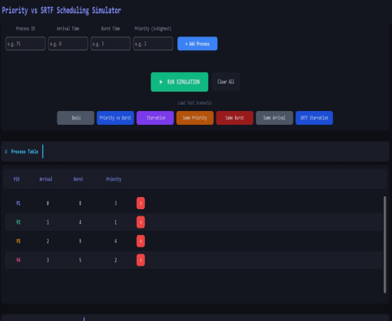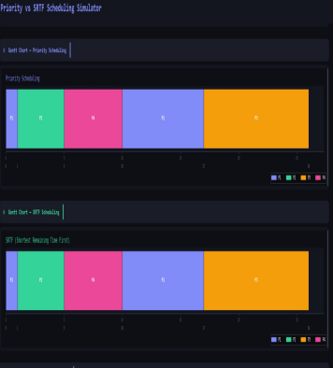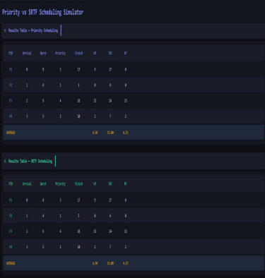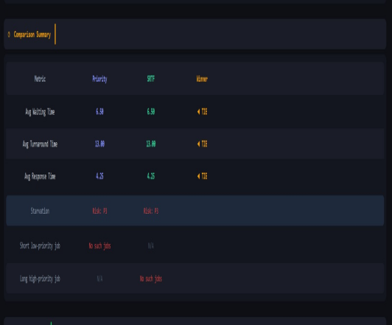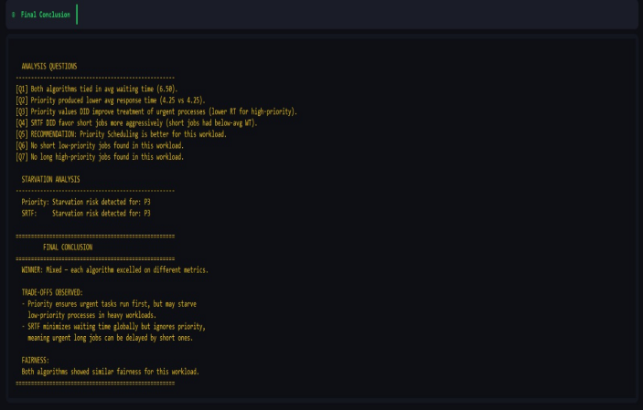

Scenario 2: B: Priority vs Burst
Tests the conflict between priority and burst time. P1 has the highest priority (1) but the longest burst (12). Shorter but lower-priority processes arrive later.

Input Processes:
Process ID | Arrival Time | Burst Time | Priority
P1 | 0 | 12 | 1
P2 | 2 | 2 | 4
P3 | 3 | 3 | 5
P4 | 5 | 1 | 3

Priority Scheduling Results:
PID | AT | BT | PR | FT | TAT = FT - AT | WT = TAT - BT | RT = First CPU - AT
P1 | 0 | 12 | 1 | 12 | TAT = FT - AT = 12 - 0 = 12 | WT = TAT - BT = 12 - 12 = 0 | RT = First CPU - AT = 0 - 0 = 0
P2 | 2 | 2 | 4 | 15 | TAT = FT - AT = 15 - 2 = 13 | WT = TAT - BT = 13 - 2 = 11 | RT = First CPU - AT = 13 - 2 = 11
P3 | 3 | 3 | 5 | 18 | TAT = FT - AT = 18 - 3 = 15 | WT = TAT - BT = 15 - 3 = 12 | RT = First CPU - AT = 15 - 3 = 12
P4 | 5 | 1 | 3 | 13 | TAT = FT - AT = 13 - 5 = 8 | WT = TAT - BT = 8 - 1 = 7 | RT = First CPU - AT = 12 - 5 = 7
AVG |  |  |  |  | Avg TAT = (12+13+15+8)/ 4 = 12.00 | Avg WT = (0+11+12+7)/ 4 = 7.50 | Avg RT = (0+11+12+7)/ 4 = 7.50
Execution Order: P1[0-12] → P4[12-13] → P2[13-15] → P3[15-18]

SRTF Results:
PID | AT | BT | PR | FT | TAT = FT - AT | WT = TAT - BT | RT = First CPU - AT
P1 | 0 | 12 | 1 | 18 | TAT = FT - AT = 18 - 0 = 18 | WT = TAT - BT = 18 - 12 = 6 | RT = First CPU - AT = 0 - 0 = 0
P2 | 2 | 2 | 4 | 4 | TAT = FT - AT = 4 - 2 = 2 | WT = TAT - BT = 2 - 2 = 0 | RT = First CPU - AT = 2 - 2 = 0
P3 | 3 | 3 | 5 | 8 | TAT = FT - AT = 8 - 3 = 5 | WT = TAT - BT = 5 - 3 = 2 | RT = First CPU - AT = 4 - 3 = 1
P4 | 5 | 1 | 3 | 6 | TAT = FT - AT = 6 - 5 = 1 | WT = TAT - BT = 1 - 1 = 0 | RT = First CPU - AT = 5 - 5 = 0
AVG |  |  |  |  | Avg TAT = (18+2+5+1)/ 4 = 6.50 | Avg WT = (6+0+2+0)/ 4 = 2.00 | Avg RT = (0+0+1+0)/ 4 = 0.25
Execution Order: P1[0-2] → P2[2-4] → P3[4-5] → P4[5-6] → P3[6-8] → P1[8-18]

Quick Comparison:
Metric | Priority | SRTF | Winner
Avg Waiting Time | 7.50 | 2.00 | SRTF
Avg Turnaround Time | 12.00 | 6.50 | SRTF
Starvation Risk (Priority) | None | - | None
Starvation Risk (SRTF) | - | Yes: P1 | Risk detected

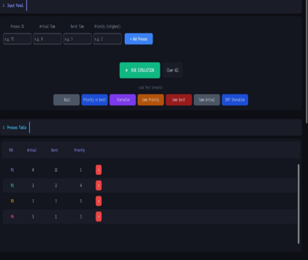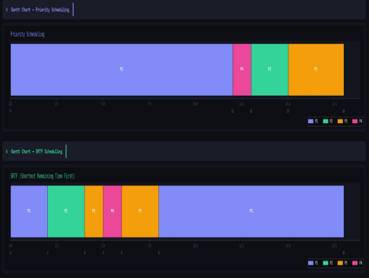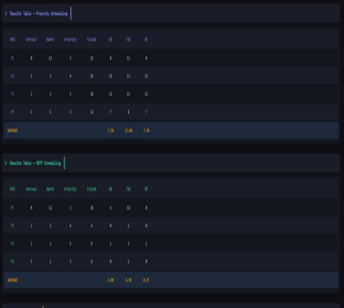
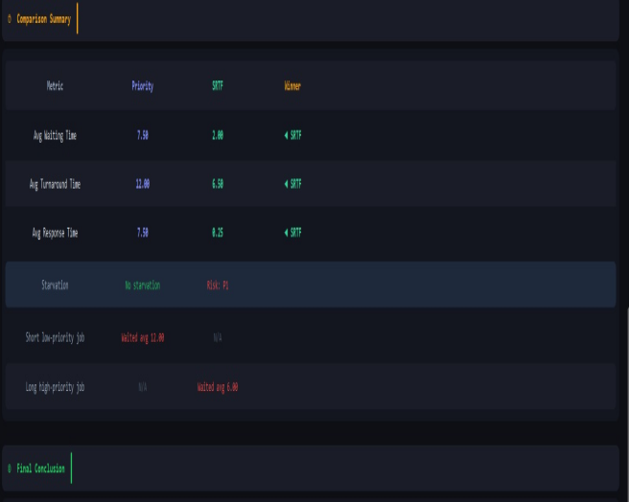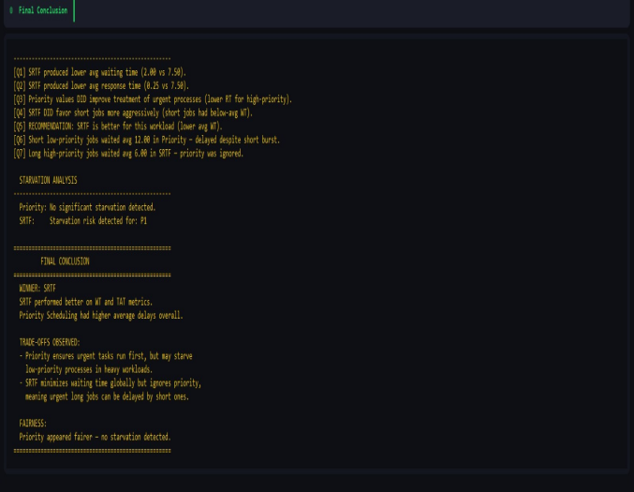
Scenario 3: C: Starvation
Designed to trigger starvation in Priority Scheduling. P1 has a long burst and the lowest priority (5), while four short high-priority processes (priority 1) arrive shortly after.

Input Processes:
Process ID | Arrival Time | Burst Time | Priority
P1 | 0 | 15 | 5
P2 | 1 | 2 | 1
P3 | 2 | 2 | 1
P4 | 3 | 2 | 1
P5 | 4 | 2 | 1

Priority Scheduling Results:
PID | AT | BT | PR | FT | TAT = FT - AT | WT = TAT - BT | RT = First CPU - AT
P1 | 0 | 15 | 5 | 23 | TAT = FT - AT = 23 - 0 = 23 | WT = TAT - BT = 23 - 15 = 8 | RT = First CPU - AT = 0 - 0 = 0
P2 | 1 | 2 | 1 | 3 | TAT = FT - AT = 3 - 1 = 2 | WT = TAT - BT = 2 - 2 = 0 | RT = First CPU - AT = 1 - 1 = 0
P3 | 2 | 2 | 1 | 5 | TAT = FT - AT = 5 - 2 = 3 | WT = TAT - BT = 3 - 2 = 1 | RT = First CPU - AT = 3 - 2 = 1
P4 | 3 | 2 | 1 | 7 | TAT = FT - AT = 7 - 3 = 4 | WT = TAT - BT = 4 - 2 = 2 | RT = First CPU - AT = 5 - 3 = 2
P5 | 4 | 2 | 1 | 9 | TAT = FT - AT = 9 - 4 = 5 | WT = TAT - BT = 5 - 2 = 3 | RT = First CPU - AT = 7 - 4 = 3
AVG |  |  |  |  | Avg TAT = (23+2+3+4+5)/ 5 = 7.40 | Avg WT = (8+0+1+2+3)/ 5 = 2.80 | Avg RT = (0+0+1+2+3)/ 5 = 1.20
Execution Order: P1[0-1] → P2[1-3] → P3[3-5] → P4[5-7] → P5[7-9] → P1[9-23]

SRTF Results:
PID | AT | BT | PR | FT | TAT = FT - AT | WT = TAT - BT | RT = First CPU - AT
P1 | 0 | 15 | 5 | 23 | TAT = FT - AT = 23 - 0 = 23 | WT = TAT - BT = 23 - 15 = 8 | RT = First CPU - AT = 0 - 0 = 0
P2 | 1 | 2 | 1 | 3 | TAT = FT - AT = 3 - 1 = 2 | WT = TAT - BT = 2 - 2 = 0 | RT = First CPU - AT = 1 - 1 = 0
P3 | 2 | 2 | 1 | 5 | TAT = FT - AT = 5 - 2 = 3 | WT = TAT - BT = 3 - 2 = 1 | RT = First CPU - AT = 3 - 2 = 1
P4 | 3 | 2 | 1 | 7 | TAT = FT - AT = 7 - 3 = 4 | WT = TAT - BT = 4 - 2 = 2 | RT = First CPU - AT = 5 - 3 = 2
P5 | 4 | 2 | 1 | 9 | TAT = FT - AT = 9 - 4 = 5 | WT = TAT - BT = 5 - 2 = 3 | RT = First CPU - AT = 7 - 4 = 3
AVG |  |  |  |  | Avg TAT = (23+2+3+4+5)/ 5 = 7.40 | Avg WT = (8+0+1+2+3)/ 5 = 2.80 | Avg RT = (0+0+1+2+3)/ 5 = 1.20
Execution Order: P1[0-1] → P2[1-3] → P3[3-5] → P4[5-7] → P5[7-9] → P1[9-23]

Quick Comparison:
Metric | Priority | SRTF | Winner
Avg Waiting Time | 2.80 | 2.80 | Tie
Avg Turnaround Time | 7.40 | 7.40 | Tie
Starvation Risk (Priority) | Yes: P1 | - | Risk detected
Starvation Risk (SRTF) | - | Yes: P1 | Risk detected

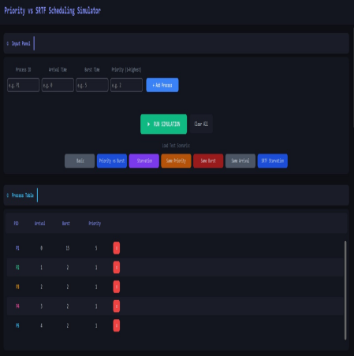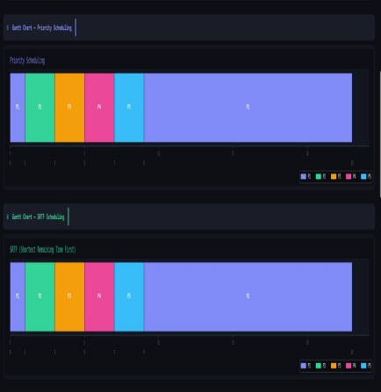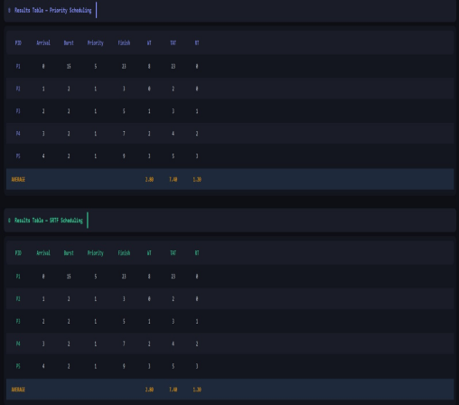

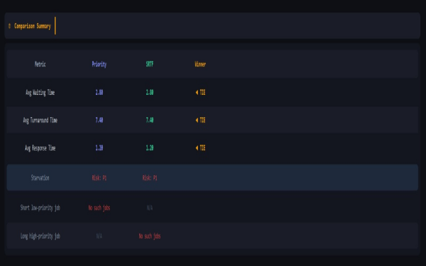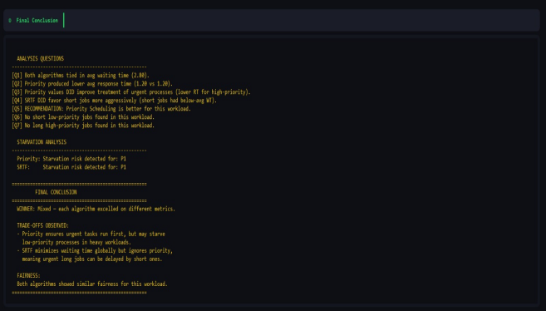

Scenario 4: Same Priority
All processes share the same priority (2). This isolates SRTF behavior and tests tie-breaking in Priority Scheduling.

Input Processes:
Process ID | Arrival Time | Burst Time | Priority
P1 | 0 | 6 | 2
P2 | 1 | 2 | 2
P3 | 3 | 8 | 2
P4 | 4 | 3 | 2

Priority Scheduling Results:
PID | AT | BT | PR | FT | TAT = FT - AT | WT = TAT - BT | RT = First CPU - AT
P1 | 0 | 6 | 2 | 6 | TAT = FT - AT = 6 - 0 = 6 | WT = TAT - BT = 6 - 6 = 0 | RT = First CPU - AT = 0 - 0 = 0
P2 | 1 | 2 | 2 | 8 | TAT = FT - AT = 8 - 1 = 7 | WT = TAT - BT = 7 - 2 = 5 | RT = First CPU - AT = 6 - 1 = 5
P3 | 3 | 8 | 2 | 16 | TAT = FT - AT = 16 - 3 = 13 | WT = TAT - BT = 13 - 8 = 5 | RT = First CPU - AT = 8 - 3 = 5
P4 | 4 | 3 | 2 | 19 | TAT = FT - AT = 19 - 4 = 15 | WT = TAT - BT = 15 - 3 = 12 | RT = First CPU - AT = 16 - 4 = 12
AVG |  |  |  |  | Avg TAT = (6+7+13+15)/ 4 = 10.25 | Avg WT = (0+5+5+12)/ 4 = 5.50 | Avg RT = (0+5+5+12)/ 4 = 5.50
Execution Order: P1[0-6] → P2[6-8] → P3[8-16] → P4[16-19]

SRTF Results:
PID | AT | BT | PR | FT | TAT = FT - AT | WT = TAT - BT | RT = First CPU - AT
P1 | 0 | 6 | 2 | 11 | TAT = FT - AT = 11 - 0 = 11 | WT = TAT - BT = 11 - 6 = 5 | RT = First CPU - AT = 0 - 0 = 0
P2 | 1 | 2 | 2 | 3 | TAT = FT - AT = 3 - 1 = 2 | WT = TAT - BT = 2 - 2 = 0 | RT = First CPU - AT = 1 - 1 = 0
P3 | 3 | 8 | 2 | 19 | TAT = FT - AT = 19 - 3 = 16 | WT = TAT - BT = 16 - 8 = 8 | RT = First CPU - AT = 11 - 3 = 8
P4 | 4 | 3 | 2 | 7 | TAT = FT - AT = 7 - 4 = 3 | WT = TAT - BT = 3 - 3 = 0 | RT = First CPU - AT = 4 - 4 = 0
AVG |  |  |  |  | Avg TAT = (11+2+16+3)/ 4 = 8.00 | Avg WT = (5+0+8+0)/ 4 = 3.25 | Avg RT = (0+0+8+0)/ 4 = 2.00
Execution Order: P1[0-1] → P2[1-3] → P1[3-4] → P4[4-7] → P1[7-11] → P3[11-19]

Quick Comparison:
Metric | Priority | SRTF | Winner
Avg Waiting Time | 5.50 | 3.25 | SRTF
Avg Turnaround Time | 10.25 | 8.00 | SRTF
Starvation Risk (Priority) | Yes: P4 | - | Risk detected
Starvation Risk (SRTF) | - | Yes: P3 | Risk detected

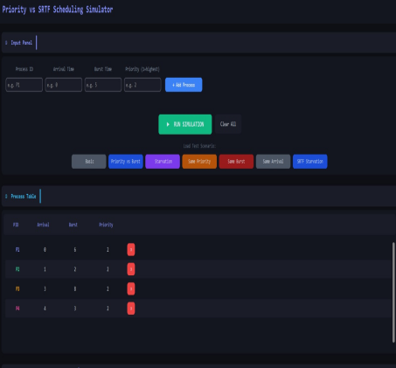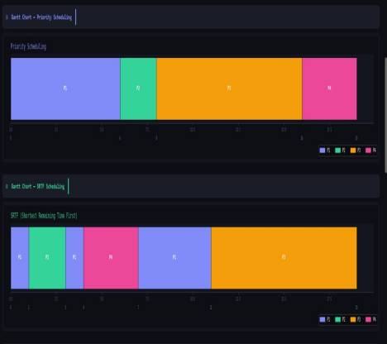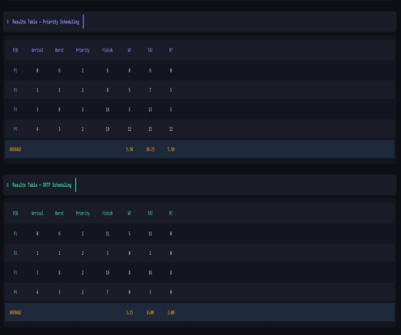
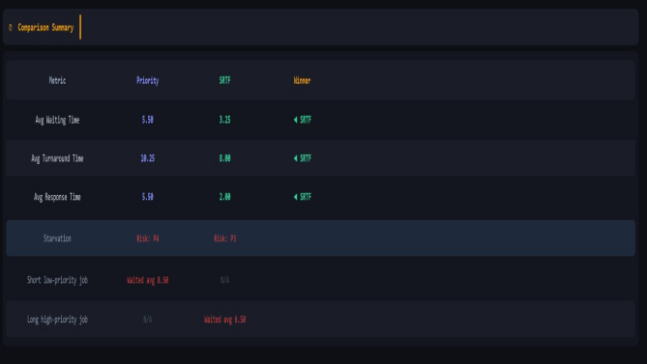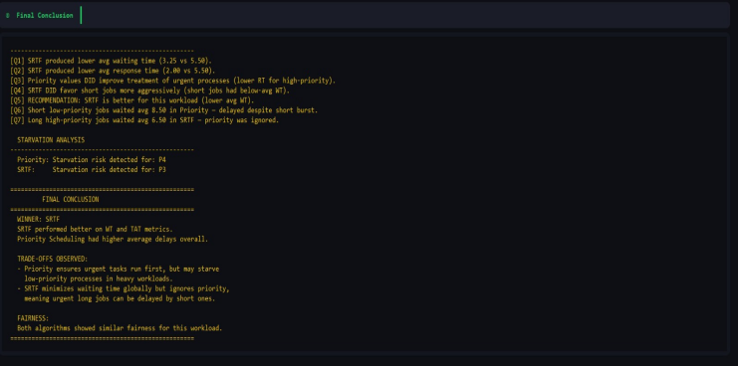
Scenario 5: Same Burst
All processes share the same burst time (5). Tests pure priority ordering and SRTF tie-breaking behavior.

Input Processes:
Process ID | Arrival Time | Burst Time | Priority
P1 | 0 | 5 | 3
P2 | 1 | 5 | 1
P3 | 2 | 5 | 4
P4 | 3 | 5 | 2

Priority Scheduling Results:
PID | AT | BT | PR | FT | TAT = FT - AT | WT = TAT - BT | RT = First CPU - AT
P1 | 0 | 5 | 3 | 15 | TAT = FT - AT = 15 - 0 = 15 | WT = TAT - BT = 15 - 5 = 10 | RT = First CPU - AT = 0 - 0 = 0
P2 | 1 | 5 | 1 | 6 | TAT = FT - AT = 6 - 1 = 5 | WT = TAT - BT = 5 - 5 = 0 | RT = First CPU - AT = 1 - 1 = 0
P3 | 2 | 5 | 4 | 20 | TAT = FT - AT = 20 - 2 = 18 | WT = TAT - BT = 18 - 5 = 13 | RT = First CPU - AT = 15 - 2 = 13
P4 | 3 | 5 | 2 | 11 | TAT = FT - AT = 11 - 3 = 8 | WT = TAT - BT = 8 - 5 = 3 | RT = First CPU - AT = 6 - 3 = 3
AVG |  |  |  |  | Avg TAT = (15+5+18+8)/ 4 = 11.50 | Avg WT = (10+0+13+3)/ 4 = 6.50 | Avg RT = (0+0+13+3)/ 4 = 4.00
Execution Order: P1[0-1] → P2[1-6] → P4[6-11] → P1[11-15] → P3[15-20]

SRTF Results:
PID | AT | BT | PR | FT | TAT = FT - AT | WT = TAT - BT | RT = First CPU - AT
P1 | 0 | 5 | 3 | 5 | TAT = FT - AT = 5 - 0 = 5 | WT = TAT - BT = 5 - 5 = 0 | RT = First CPU - AT = 0 - 0 = 0
P2 | 1 | 5 | 1 | 10 | TAT = FT - AT = 10 - 1 = 9 | WT = TAT - BT = 9 - 5 = 4 | RT = First CPU - AT = 5 - 1 = 4
P3 | 2 | 5 | 4 | 15 | TAT = FT - AT = 15 - 2 = 13 | WT = TAT - BT = 13 - 5 = 8 | RT = First CPU - AT = 10 - 2 = 8
P4 | 3 | 5 | 2 | 20 | TAT = FT - AT = 20 - 3 = 17 | WT = TAT - BT = 17 - 5 = 12 | RT = First CPU - AT = 15 - 3 = 12
AVG |  |  |  |  | Avg TAT = (5+9+13+17)/ 4 = 11.00 | Avg WT = (0+4+8+12)/ 4 = 6.00 | Avg RT = (0+4+8+12)/ 4 = 6.00
Execution Order: P1[0-5] → P2[5-10] → P3[10-15] → P4[15-20]

Quick Comparison:
Metric | Priority | SRTF | Winner
Avg Waiting Time | 6.50 | 6.00 | SRTF
Avg Turnaround Time | 11.50 | 11.00 | SRTF
Starvation Risk (Priority) | None | - | None
Starvation Risk (SRTF) | - | None | None

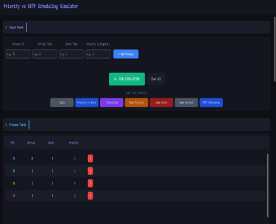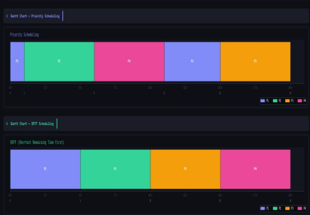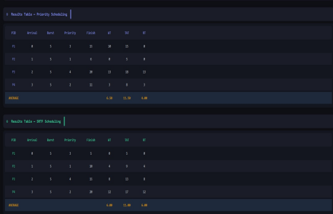

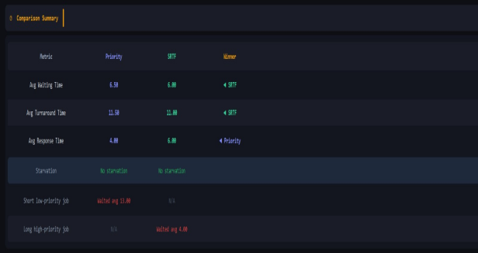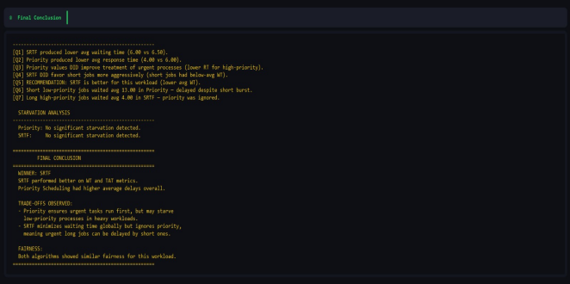

Scenario 6: Same Arrival
All processes arrive simultaneously at time 0. Tests scheduling decision-making without the complication of staggered arrivals.

Input Processes:
Process ID | Arrival Time | Burst Time | Priority
P1 | 0 | 7 | 2
P2 | 0 | 3 | 4
P3 | 0 | 5 | 1
P4 | 0 | 2 | 3

Priority Scheduling Results:
PID | AT | BT | PR | FT | TAT = FT - AT | WT = TAT - BT | RT = First CPU - AT
P1 | 0 | 7 | 2 | 12 | TAT = FT - AT = 12 - 0 = 12 | WT = TAT - BT = 12 - 7 = 5 | RT = First CPU - AT = 5 - 0 = 5
P2 | 0 | 3 | 4 | 17 | TAT = FT - AT = 17 - 0 = 17 | WT = TAT - BT = 17 - 3 = 14 | RT = First CPU - AT = 14 - 0 = 14
P3 | 0 | 5 | 1 | 5 | TAT = FT - AT = 5 - 0 = 5 | WT = TAT - BT = 5 - 5 = 0 | RT = First CPU - AT = 0 - 0 = 0
P4 | 0 | 2 | 3 | 14 | TAT = FT - AT = 14 - 0 = 14 | WT = TAT - BT = 14 - 2 = 12 | RT = First CPU - AT = 12 - 0 = 12
AVG |  |  |  |  | Avg TAT = (12+17+5+14)/ 4 = 12.00 | Avg WT = (5+14+0+12)/ 4 = 7.75 | Avg RT = (5+14+0+12)/ 4 = 7.75
Execution Order: P3[0-5] → P1[5-12] → P4[12-14] → P2[14-17]

SRTF Results:
PID | AT | BT | PR | FT | TAT = FT - AT | WT = TAT - BT | RT = First CPU - AT
P1 | 0 | 7 | 2 | 17 | TAT = FT - AT = 17 - 0 = 17 | WT = TAT - BT = 17 - 7 = 10 | RT = First CPU - AT = 10 - 0 = 10
P2 | 0 | 3 | 4 | 5 | TAT = FT - AT = 5 - 0 = 5 | WT = TAT - BT = 5 - 3 = 2 | RT = First CPU - AT = 2 - 0 = 2
P3 | 0 | 5 | 1 | 10 | TAT = FT - AT = 10 - 0 = 10 | WT = TAT - BT = 10 - 5 = 5 | RT = First CPU - AT = 5 - 0 = 5
P4 | 0 | 2 | 3 | 2 | TAT = FT - AT = 2 - 0 = 2 | WT = TAT - BT = 2 - 2 = 0 | RT = First CPU - AT = 0 - 0 = 0
AVG |  |  |  |  | Avg TAT = (17+5+10+2)/ 4 = 8.50 | Avg WT = (10+2+5+0)/ 4 = 4.25 | Avg RT = (10+2+5+0)/ 4 = 4.25
Execution Order: P4[0-2] → P2[2-5] → P3[5-10] → P1[10-17]

Quick Comparison:
Metric | Priority | SRTF | Winner
Avg Waiting Time | 7.75 | 4.25 | SRTF
Avg Turnaround Time | 12.00 | 8.50 | SRTF
Starvation Risk (Priority) | None | - | None
Starvation Risk (SRTF) | - | Yes: P1 | Risk detected

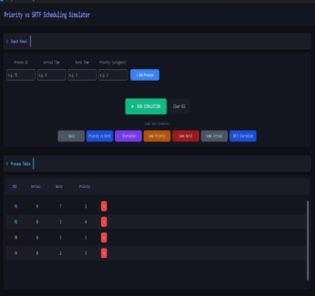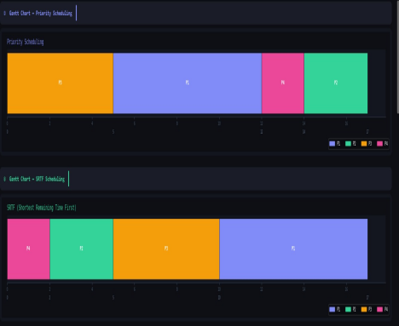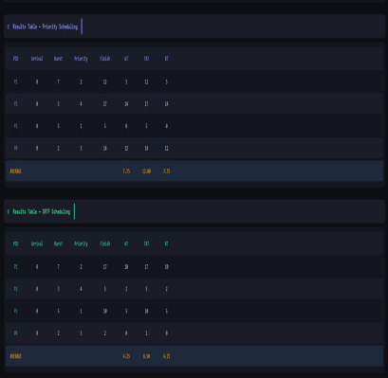

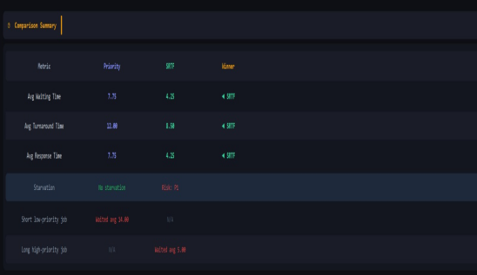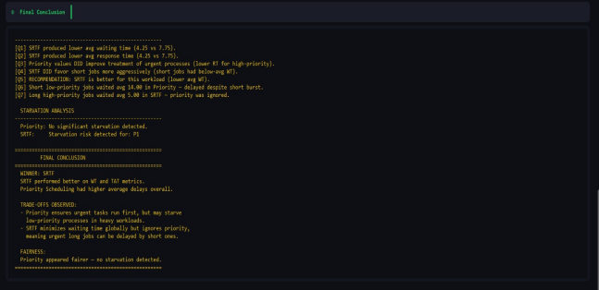

Scenario 7: SRTF Starvation
Designed to trigger starvation in SRTF. P1 has a very long burst (20), while four short processes arrive successively, continuously preempting P1.

Input Processes:
Process ID | Arrival Time | Burst Time | Priority
P1 | 0 | 20 | 1
P2 | 2 | 3 | 3
P3 | 4 | 2 | 3
P4 | 6 | 1 | 3
P5 | 8 | 2 | 3

Priority Scheduling Results:
PID | AT | BT | PR | FT | TAT = FT - AT | WT = TAT - BT | RT = First CPU - AT
P1 | 0 | 20 | 1 | 20 | TAT = FT - AT = 20 - 0 = 20 | WT = TAT - BT = 20 - 20 = 0 | RT = First CPU - AT = 0 - 0 = 0
P2 | 2 | 3 | 3 | 23 | TAT = FT - AT = 23 - 2 = 21 | WT = TAT - BT = 21 - 3 = 18 | RT = First CPU - AT = 20 - 2= 18
P3 | 4 | 2 | 3 | 25 | TAT = FT - AT = 25 - 4 = 21 | WT = TAT - BT = 21 - 2 = 19 | RT = First CPU - AT = 23 - 4= 19
P4 | 6 | 1 | 3 | 26 | TAT = FT - AT = 26 - 6 = 20 | WT = TAT - BT = 20 - 1 = 19 | RT = First CPU - AT = 25 - 6 = 19
P5 | 8 | 2 | 3 | 28 | TAT = FT - AT = 28 - 8 = 20 | WT = TAT - BT = 20 - 2 = 18 | RT = First CPU - AT = 26 - 8 = 18
AVG |  |  |  |  | Avg TAT = (20+21+21+20+20)/ 5 = 20.4 | Avg WT = (0+18+19+19+18)/ 5 = 14.8 | Avg RT = (0+18+19+19+18)/ 5 =14.8
Execution Order: P1[0-1] → P2[1-3] → P3[3-5] → P4[5-7] → P5[7-9] → P1[9-28]

SRTF Results:
PID | AT | BT | PR | FT | TAT = FT - AT | WT = TAT - BT | RT = First CPU - AT
P1 | 0 | 20 | 1 | 28 | TAT = FT - AT = 28 - 0 = 28 | WT = TAT - BT = 28 - 20 = 8 | RT = First CPU - AT = 0 - 0 = 0
P2 | 2 | 3 | 3 | 5 | TAT = FT - AT = 5 - 2 = 3 | WT = TAT - BT = 3 - 3= 0 | RT = First CPU - AT = 3- 2 = 0
P3 | 4 | 2 | 3 | 7 | TAT = FT - AT = 7 - 4 = 3 | WT = TAT - BT = 3 - 2 = 1 | RT = First CPU - AT = 5 - 4 = 1
P4 | 6 | 1 | 3 | 8 | TAT = FT - AT = 8 - 6 = 2 | WT = TAT - BT = 2 - 1 = 1 | RT = First CPU - AT = 7- 6= 1
P5 | 8 | 2 | 3 | 10 | TAT = FT - AT = 10- 8 = 2 | WT = TAT - BT = 2 - 2 = 0 | RT = First CPU - AT = 8 - 8 = 0
AVG |  |  |  |  | Avg TAT = (28+3+3+2+2)/ 5 = 2 | Avg WT = (8+0+1+1+0)/ 5 = 7.6 | Avg RT = (0+0+1+1+0)/ 5 = 0.40
Execution Order: P1[0-1] → P2[1-3] → P3[3-5] → P4[5-7] → P5[7-9] → P1[9-28]

Quick Comparison:
Metric | Priority | SRTF | Winner
Avg Waiting Time | 14.8 | 2 | Tie
Avg Turnaround Time | 20.4 | 7.6 | Tie
Starvation Risk (Priority) |  |  | Risk detected
Starvation Risk (SRTF) | - | Yes: P1 | Risk detected

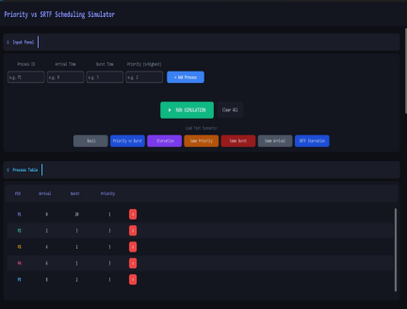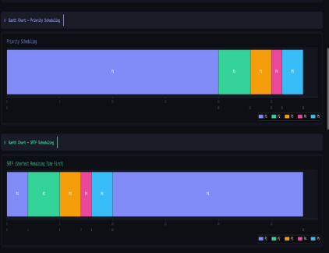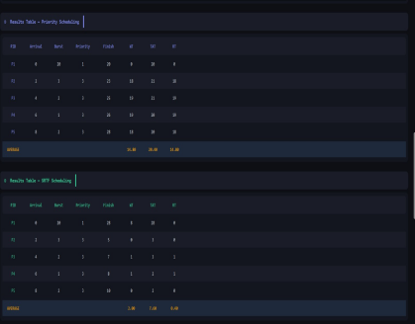
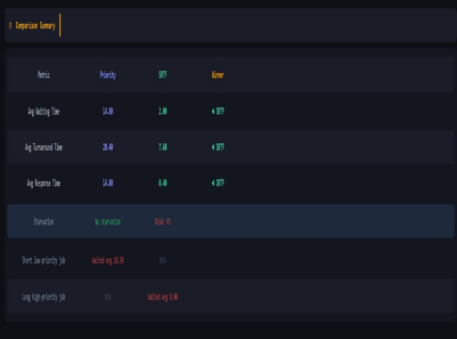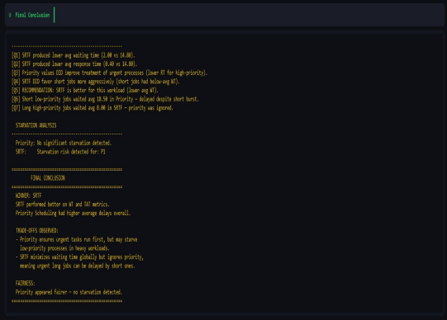

4. Comparison & Analysis

Q1: Which algorithm produced a lower average waiting time?
SRTF achieves lower average waiting time because it continuously selects the shortest remaining job, minimizing the time other processes spend in the queue. However, in scenarios where priority numbers closely align with burst times (e.g., high-priority processes happen to be short), Priority Scheduling can match or outperform SRTF.

Q2: Which algorithm produced a lower average response time?
Response time measures how quickly a process first receives CPU attention. Priority Scheduling typically achieves lower response times for high-priority processes because they are served as soon as they arrive, regardless of burst length. SRTF may delay long processes significantly before their first CPU execution.

Q3: Did priority values improve the treatment of urgent processes in Priority Scheduling?
Yes. In Priority Scheduling, the process with the lowest priority number (highest urgency) consistently receives CPU attention first upon arrival, regardless of its burst time. In Scenario B (Priority vs. Burst), P1 with priority 1 and burst 12 runs uninterrupted from time 0, demonstrating that urgent processes are protected from being delayed by shorter but less critical processes. This is the primary advantage of priority-based scheduling in real-time or mixed-criticality systems.

Q4: Did SRTF show more aggressive favoritism toward short processes?
Yes, consistently across all scenarios. SRTF's core mechanism is to always select the shortest remaining job, which means short processes experience near-zero waiting time while long processes may be heavily delayed. In Scenario SRTF Starvation, P1 with burst 20 is repeatedly preempted by P2–P5 (bursts 3, 2, 1, 2), causing P1 to wait until all short processes complete before it can make progress. This aggressive short-job favoritism makes SRTF optimal for throughput but problematic for fairness.

Q5: Overall recommendation — which algorithm performs better?
SRTF is generally recommended for environments where minimizing average waiting time and maximizing throughput are the primary goals, such as batch processing systems. Priority Scheduling is recommended when task urgency is known and must be respected, such as in real-time systems, operating system kernel task management, or multi-tier service systems. The choice depends on whether the system prioritizes fairness-by-urgency (Priority) or fairness-by-time (SRTF).

Q6: How are short low-priority jobs treated in Priority Scheduling?
Short low-priority jobs suffer a significant disadvantage in Priority Scheduling. Even if a process has a very short burst time (e.g., 2 units), if its priority number is high (low urgency), it must wait for all higher-priority processes to complete first. In Scenario C (Starvation), P1 with priority 5 and burst 15 is starved by four processes with priority 1, even though some of those processes are shorter. This confirms that Priority Scheduling can cause starvation for low-priority processes in heavy workloads.

Q7: How are long high-priority jobs treated in SRTF?
Long high-priority jobs are severely disadvantaged in SRTF because priority is completely ignored. A process with burst 20 and priority 1 (highest urgency) will be preempted by any arriving process with a shorter remaining time, regardless of how critical it is. In the SRTF Starvation scenario, P1 (burst 20) does not complete until all shorter processes finish, despite having the highest priority. This is SRTF's primary weakness in systems where some tasks must meet strict deadlines.

5. Assumptions & Limitations
5.1 Assumptions
- Burst times are known in advance. In real systems, burst times are generally unpredictable; the simulator assumes they are given as input. This is a standard assumption for theoretical algorithm analysis.
- All processes are CPU-bound. I/O operations, context switching overhead, and memory access delays are not modeled. The simulation focuses purely on scheduling logic.
- Unit-based time. Time advances in integer units. The simulation does not model fractional time slices or variable tick rates.
- Single-CPU system. Only one process can execute at any given time unit. Multi-core parallelism is out of scope.
- Processes do not generate new processes. No fork/spawn operations are modeled during simulation.
- Priority numbers are static. A process's priority does not change over time (no aging mechanism).
- Lower priority number = higher urgency. Priority 1 is the most important; higher numbers indicate lower urgency.

5.2 Limitations
- No aging mechanism. Priority Scheduling does not implement aging (gradually increasing priority of waiting processes). In real operating systems, aging prevents indefinite starvation by eventually promoting long-waiting processes.
- No I/O modeling. Real processes alternate between CPU bursts and I/O waits. The simulator only handles a single CPU burst per process, which is a simplification.
- SRTF requires future knowledge. The simulation uses actual burst times to make SRTF decisions. In practice, burst time prediction algorithms (e.g., exponential averaging) would be required.
- No priority inversion handling. SRTF does not consider priority at all; real-time OS kernels often combine burst estimation with priority to avoid priority inversion problems.
- Context switching overhead ignored. Each preemption in a real system incurs overhead (saving/restoring registers, cache invalidation). This is not modeled, so SRTF and preemptive priority algorithms theoretical advantage may be smaller in practice.
- Limited to integer inputs. Process IDs, arrival times, burst times, and priorities must be whole numbers. Floating-point values are not supported.

6. Conclusion
This report evaluated Priority Scheduling and SRTF across seven diverse test scenarios, covering normal workloads, starvation cases, same-parameter edge cases, and conflicting priority/burst configurations.
The results consistently show that SRTF achieves lower average waiting time and turnaround time in most workloads, making it theoretically optimal for throughput-oriented systems. However, its complete disregard for priority values makes it unsuitable for real-time or deadline-critical environments.
Priority Scheduling, on the other hand, reliably ensures that urgent processes receive CPU attention promptly, providing predictable behavior for high-priority tasks. Its weakness lies in potential starvation of low-priority processes under heavy load, which can be mitigated in practice through aging mechanisms.
The trade-off is clear: use SRTF when minimizing average wait time is paramount, and use Priority Scheduling when task urgency and fairness-by-importance are required. A hybrid approach combining priority with remaining-time estimation (such as Priority + SRTF) would address the weaknesses of both algorithms and represents a promising direction for practical scheduling systems.

